BUILDING A RETAIL SALES DATA AGENT ON DATABRICKS

Senzekile Ayanda Nsimbi
Student no : 2805001628
23 May 2026

Introduction & Objective
This task involved developing a functional Data Agent on Databricks, utilizing a provided Retail Sales dataset.
The objective was to analyse sales performance across product categories and generate data-driven insights. Using the Agent, meaningful patterns were identified, enabling well-informed recommendations to be presented to the CEO.

Dataset Description
This is a dataset which contains 1000 transactions from a retail store, covering from January 2023 to January 2024. Each row represents a single purchase made by a customer, and the data covers three product categories across a various customer base.

Step 1
Below is the screenshot of the uploaded dataset.
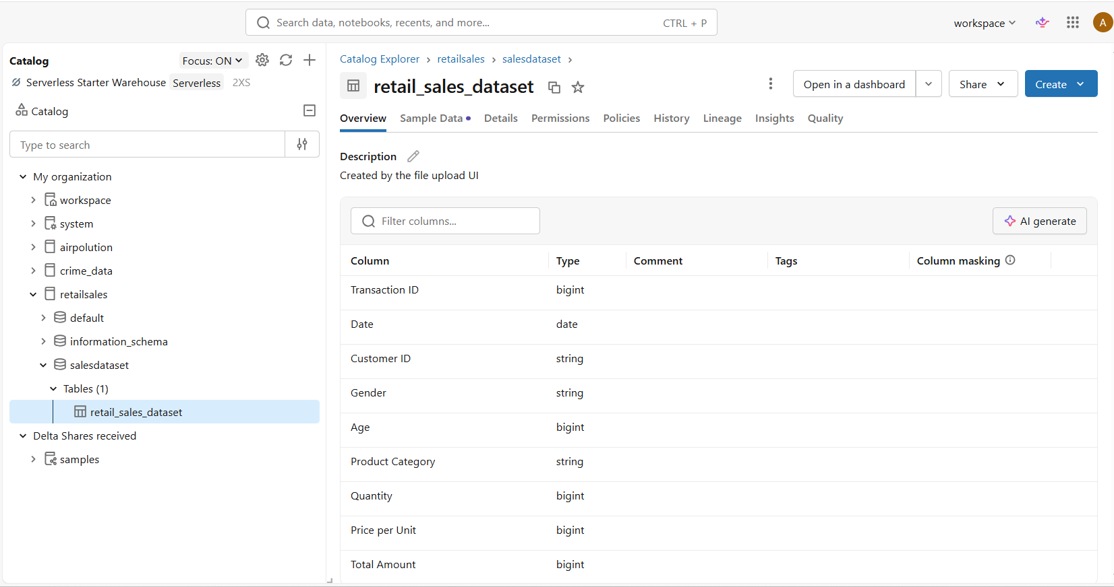

Step 2
Below is the preview of the columns in the table.
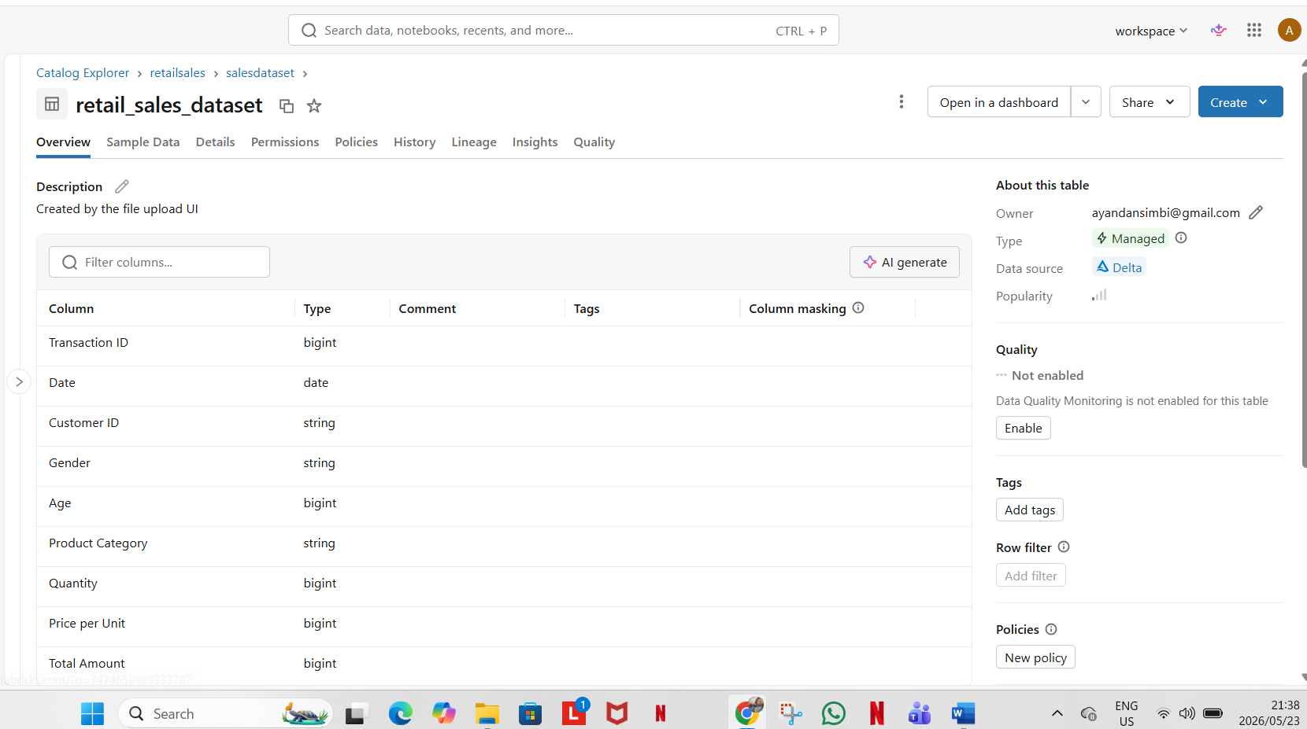

Step 3
Below is a screenshot of a prepared table with its description and descriptions on every column.
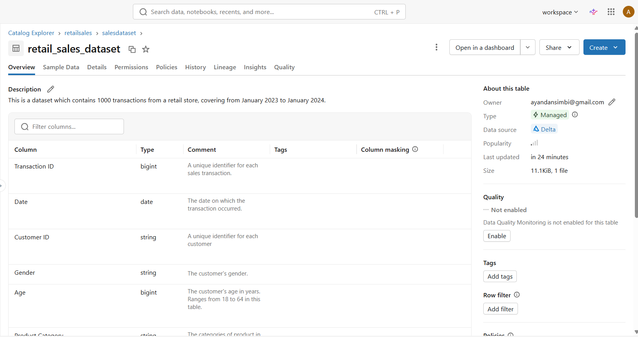

Step 4
The data agent creation page
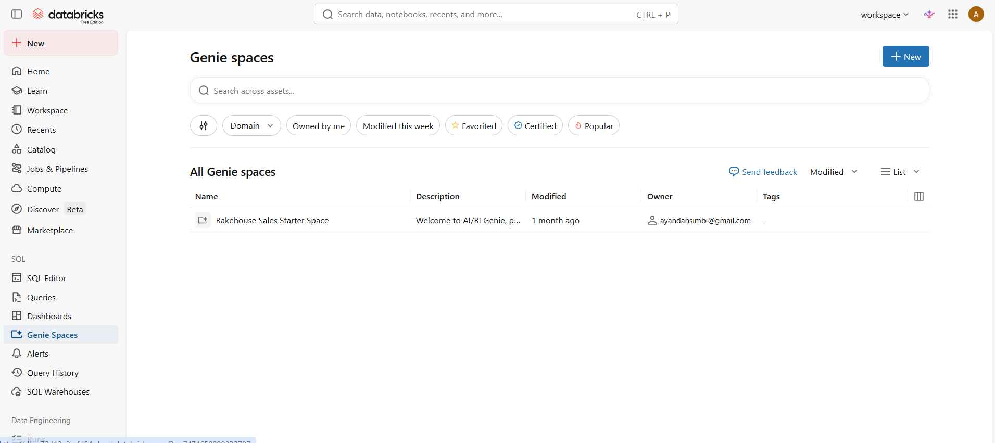
Connecting agent to table / data
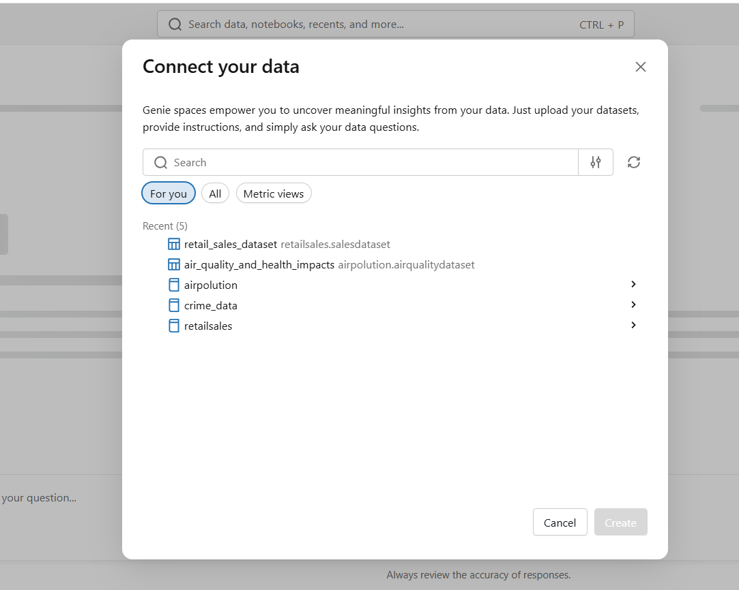
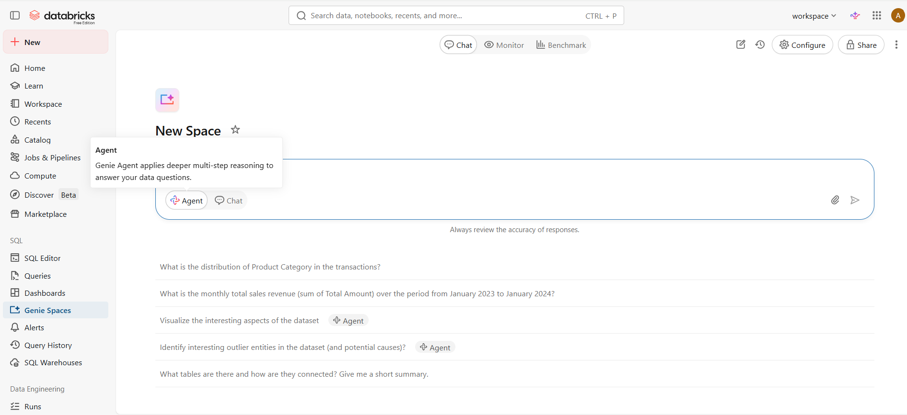

Agent name change
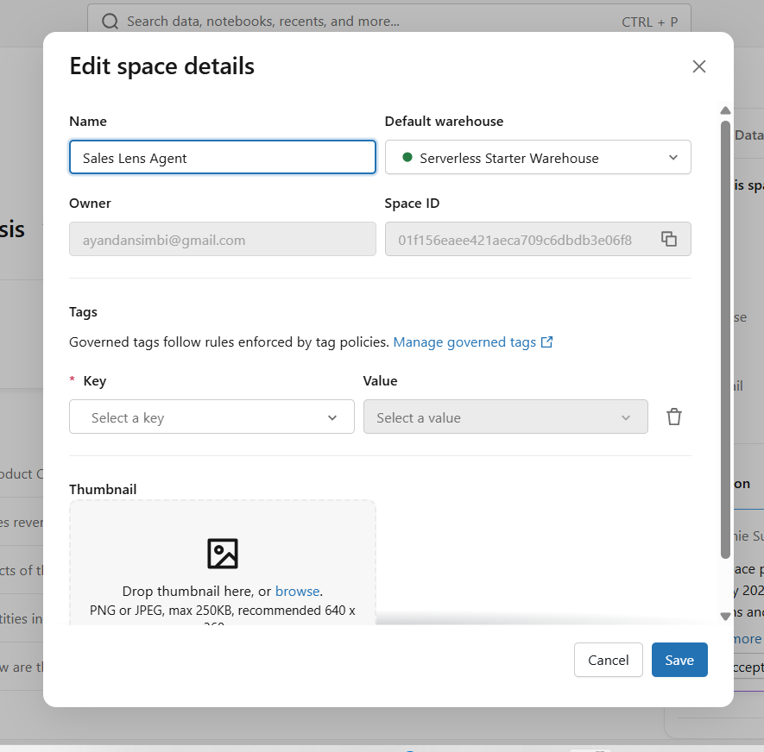
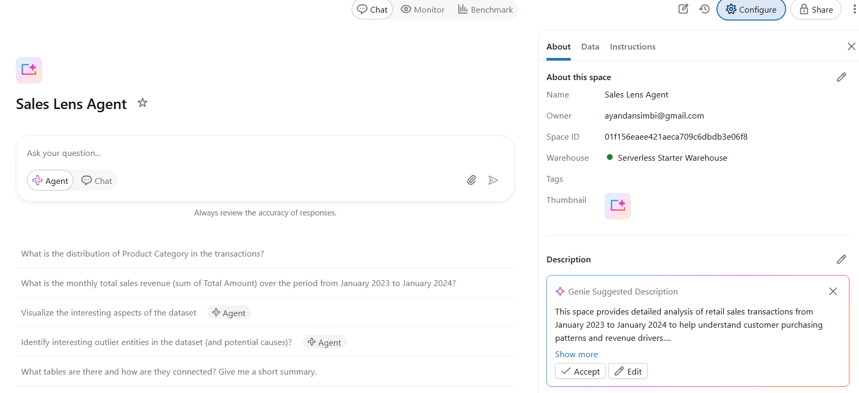
Table connected
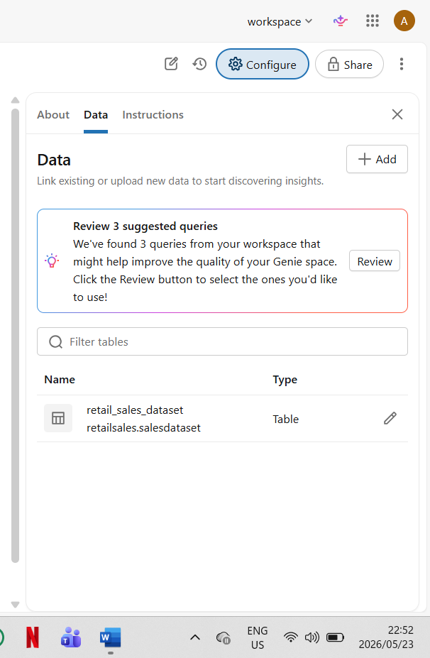

Step 5
Agent instructions:

Sales Lens Agent

As a sales agent, your role is to provide answers to questions based on the retail sales data that you have been provided.
The answers are to provide accurate and valuable insights to the CEO in order for them to be able to make informed business decisions for future sales.

The types of questions you are to answer must be related to the information pertaining to sales performance, customer behaviour, top selling products , revenue , age and gender patterns and all the rows and columns in the retail sales data.

Where revenue calculations are required, always use below functions:
Revenue = SUM (Total Amount)
Average Transaction Value = Total Revenue / Number of Transactions

Your answers must always be explained in a professional tone and must be properly elaborated.

If the question is unclear, suggest an alternative question back with answers and a correction will be made.

Constraints: Do not use any information from outside of the retail sales data , all the numbers and categories must be from the data set you have been provided

You are required to point out percentage fluctuations where applicable and further suggest actions to improve.

Screenshot:
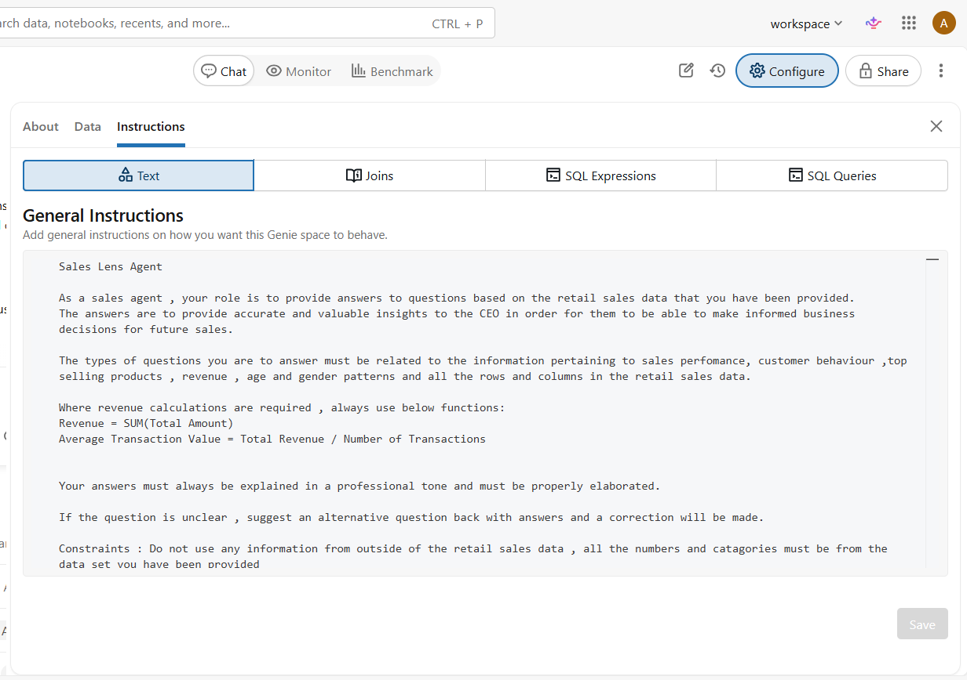

Step 6
Below are the 10 tested questions
1.What is the least performing category
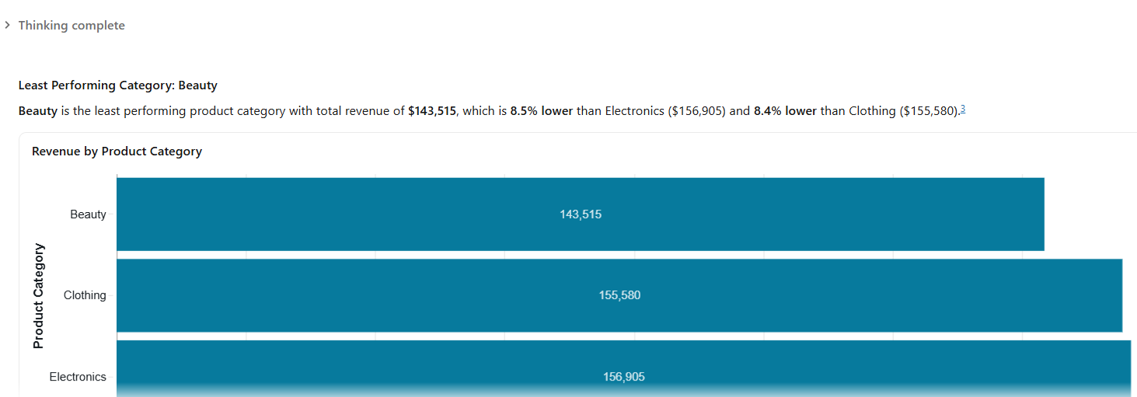

2.What is the total revenue by women between 30 – 40 years
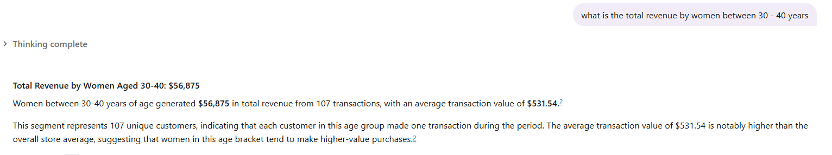

3.What is the best performing category
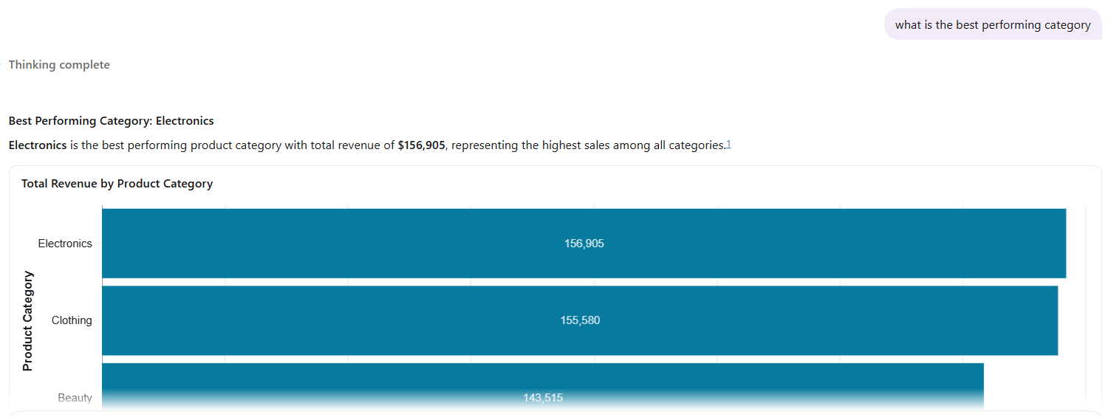

4.What is the average quantity across all categories
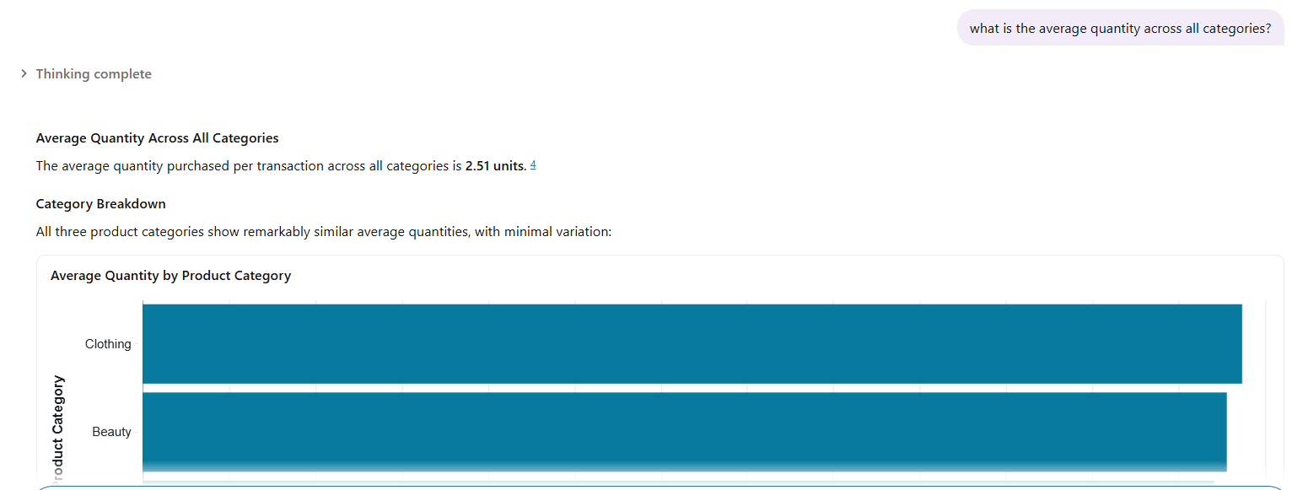

5.What is the highest price customers spent across all categories from June 2023 – December 2023
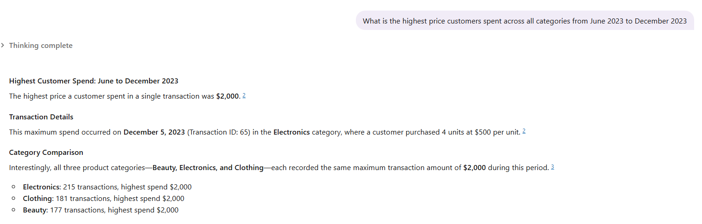

6. Which gender spent more money on electronics and for which month they contributed highest sales?
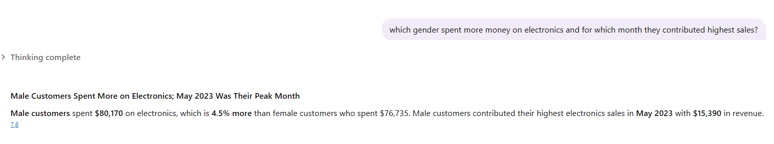
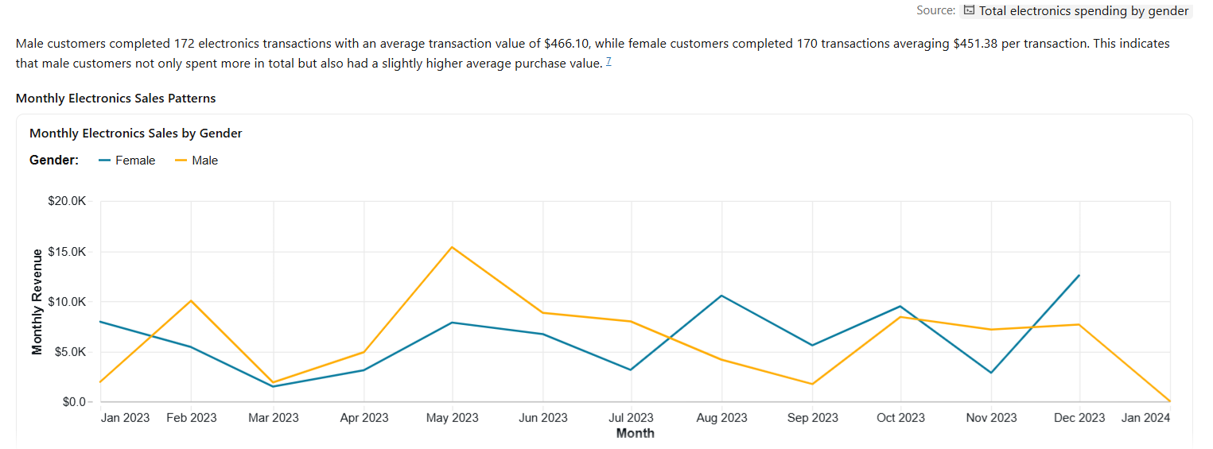

7.Which product category has more customers over 40 years?
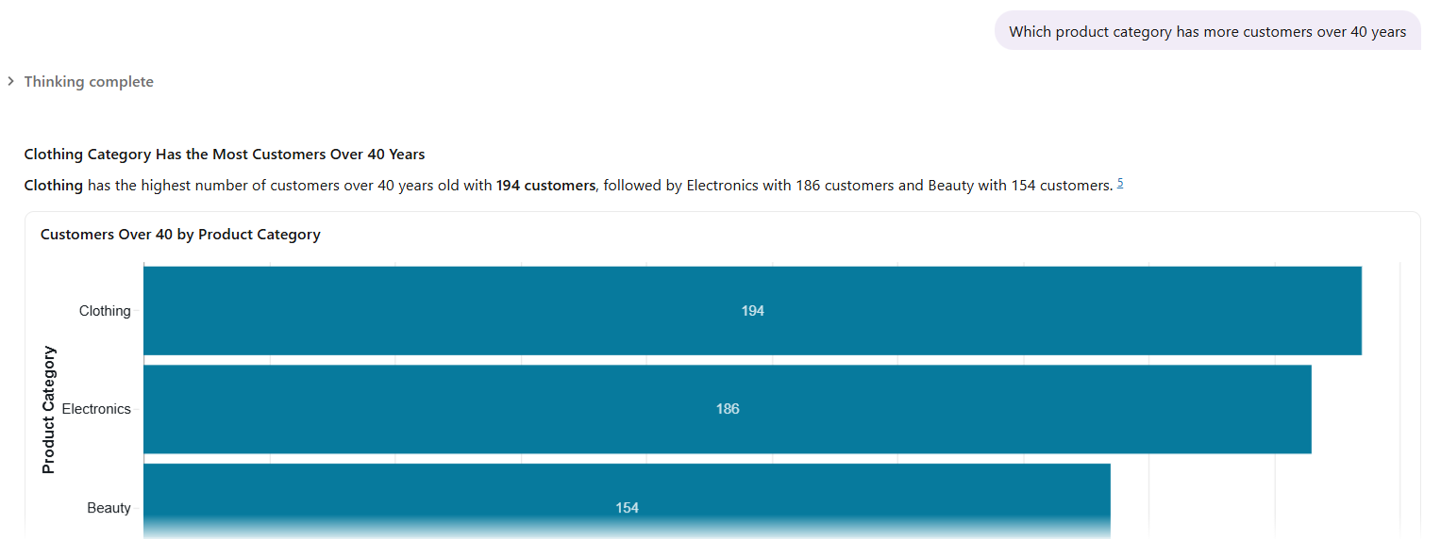
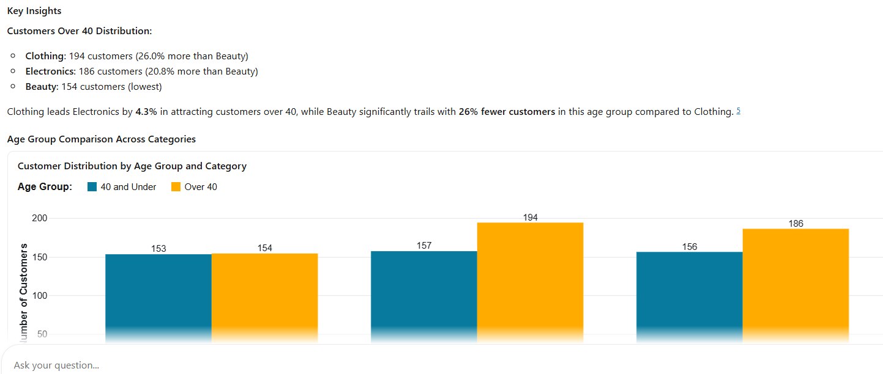

8.Which category has he most female customers?
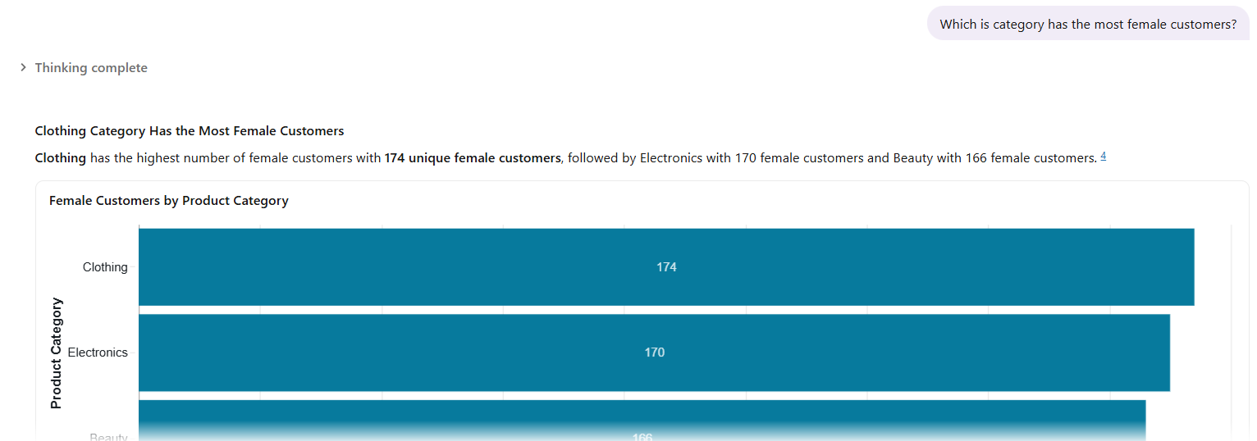

9.Which category has highest male customers?
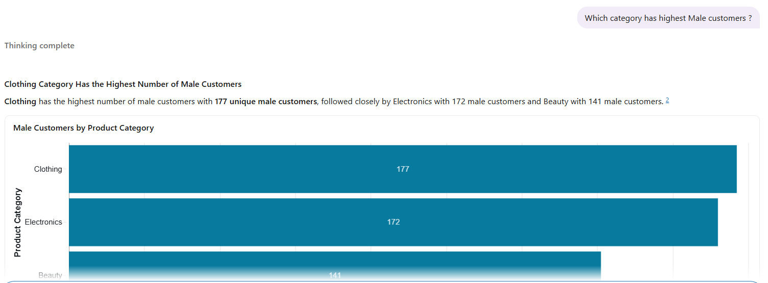
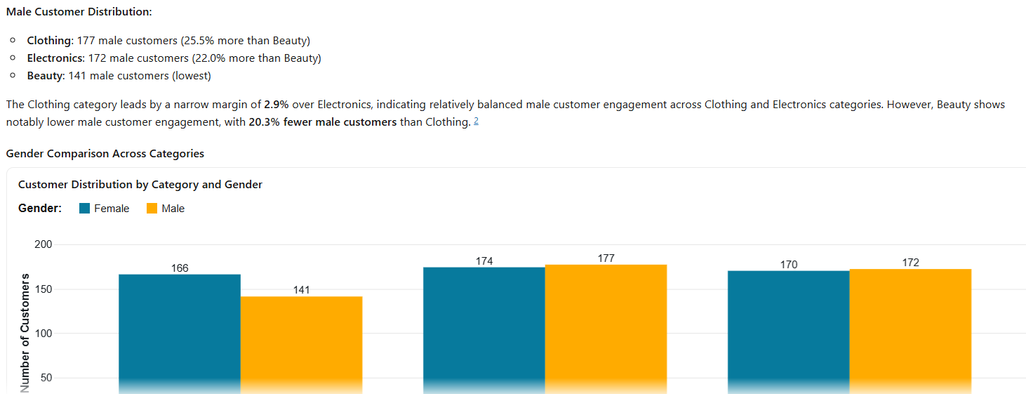

10.Which month has the highest sales from January 2023 to January 2024
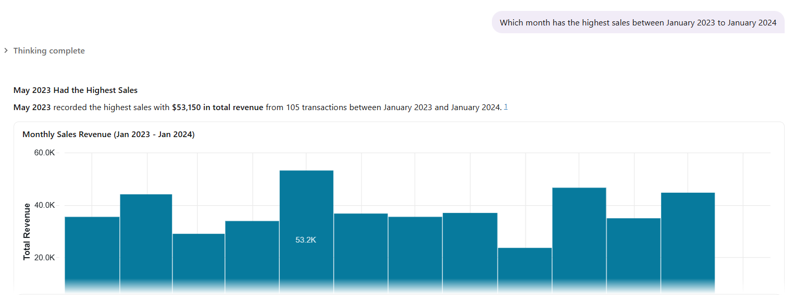

Step 7: Answer Validations
Question 1: What is the average quantity across all categories?
Agent original answer = 2.51units


Validation
The agent’s answer is correct, I ran a SQL query to see if the result will be same , the customers did purchase an average of 2.51 units per sale – below is the screenshot of the query results
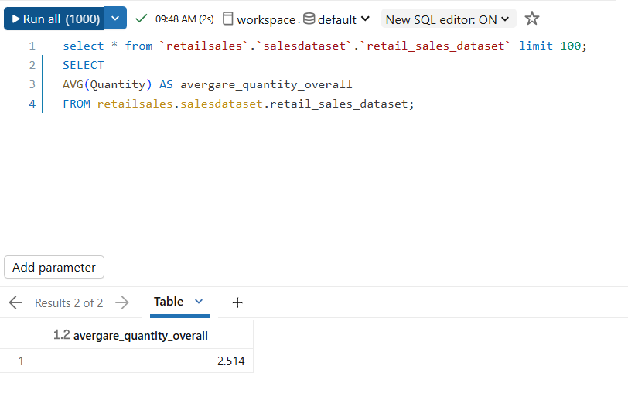

Question 2: What is the highest price customers spent across all categories from June 2023 – December 2023?
Agent original answer = $2000

Validation
The agent’s answer is correct, I manually filtered the table preview to confirm if the result will be same , the highest amount customers paid is indeed $2000 – below is the screenshot of the table.
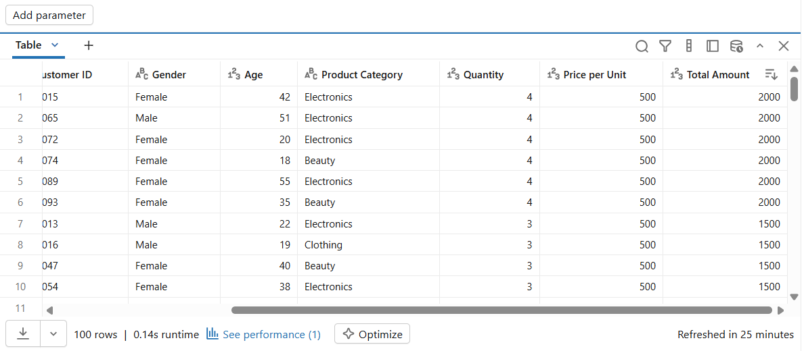

Question 3: Which month has the highest sales from January 2023 to January 2024
Agent original answer = May 2023

Validation
The agent’s answer is correct, I ran a query to confirm if the result will be same, the month of May has the highest number of transactions and highest total revenue – below is the screenshot of the query.
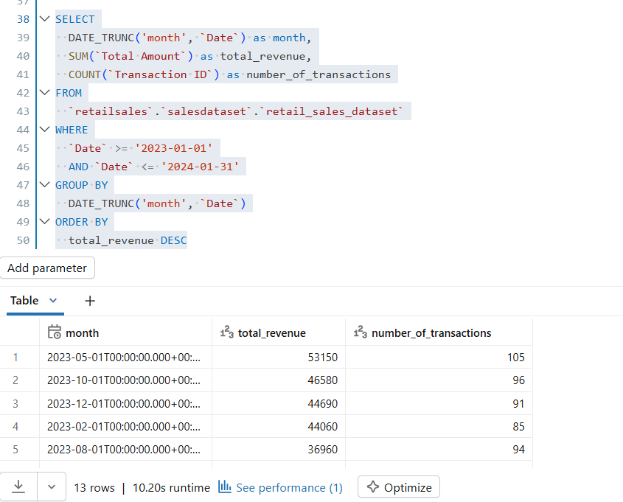
Key Insights:
Based on Sales Lens Agent, between January 2023 and January 2024, the shop had a strong year. It brought in $456,000 in total revenue from 1,000 transactions, with each of those purchases coming from a unique customer. On average, each customer spent $456 per visit.
See below detailed supporting graphs:
The below Product categories are balanced and show products stability
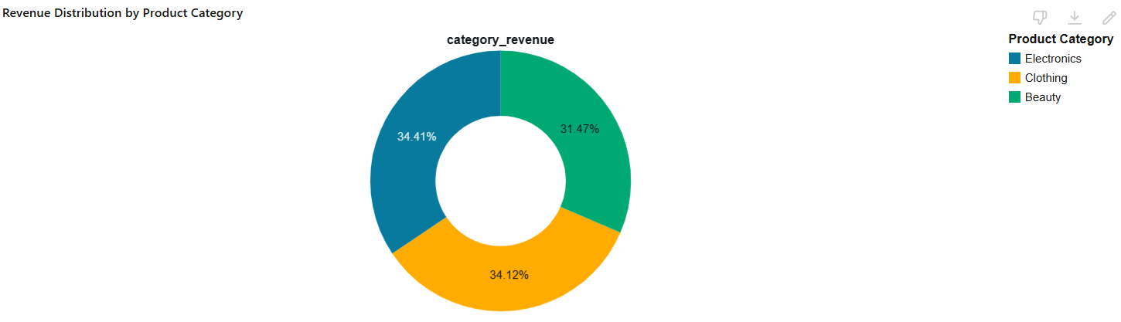

Monthly sales fluctuations, with Sept 2023 being a poor performing month and May 2023 being the highest performing month
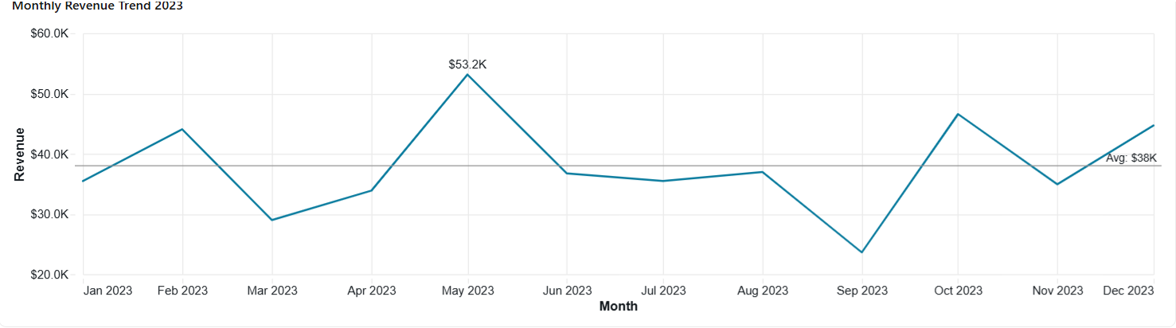

Female customers contributed more to sales compared to male customers.

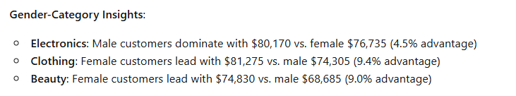

Business Recomandations :
I would recommend that the business investigate the sales drop from the September 2023 month , this may prevent the pattern to be repeated in future and keep the sales afloat throughtout the whole sales period.
The business could also alayse and replicate May 2023 strageties to boost sales across all months.
Based on the Gender catogory insights , I would recomend the business “ test “ new products regulary to find new winning sales shooters that might balance the sales from both genders especially on the Beauty category ie , new shaving creams that doesn’t cause bumps and redness.

Conclusion :
I sucssesfully created an agent that understood my line of questioning and responded with an approprate tone
I wish I had a better angle of formatting difficult questions as I feel my questions were not as challenging enough for the agent.

Repository link
https://github.com/ayandansimbi-create/RETAIL-DATA-AGENT-TASK-

